User Stories for analyzing Copy Number

- User wants to add a criterion to a compound query and query with only the amplified genes from a gene pattern GISTIC job result. In the “Gene Picker”, in the Gene Lists popup, the USBAT see the gene lists from their GISTIC job results. USBAT save this query.
- User wants to add a criterion to a compound query, and query with only the deleted genes from a gene pattern GISTIC job result. In the “Gene Picker”, in the Gene Lists popup, the USBAT see the gene lists from their GISTIC job results. USBAT save this query.
- Summary: User wants to get a list of patients/samples that have a copy number alteration greater than X at any point over an interval on the genome, where the interval is specified by the user.

Details: As a study investigator, user wants to create a query based on copy number values as determined by the caDNACopy (using CBS) algorithm. The user initiates a new query. On the Criteria tab, the user selects copy number and then add button. User sees a new criterion row labeled “Copy Number”. The user sees a dropdown selector for the interval and can choose one of the following:
- Gene Name (s) – Selecting this reveals the current “Gene Picker”.
- Chromosome Coordinates – Selecting this reveals 2 text boxes for entering 2 numeric coordinates.
- Chromosome Number – Selecting this reveals 1 text box for entering 1 thru 24.

For each of the interval options, the user sees 3 parameters:
- Genome boundaries –
  - At least one amplification or deletion segment defined by the CBS algorithm and meeting the magnitude within the defined region.
  - The amplified or deleted segment defined by the CBS algorithm includes the entire defined region
- Upper limit of the amplification - User enters X and selects “>” or “<”.
- Lower limit of the amplification - User enters X and selects “>” or “<”.

Screenshot of Copy Number criterion for Gene Name:
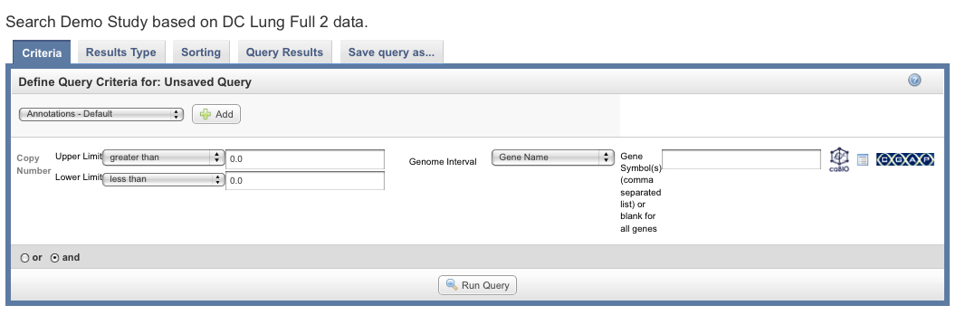

Screenshot of Copy Number criterion for Gene Name:

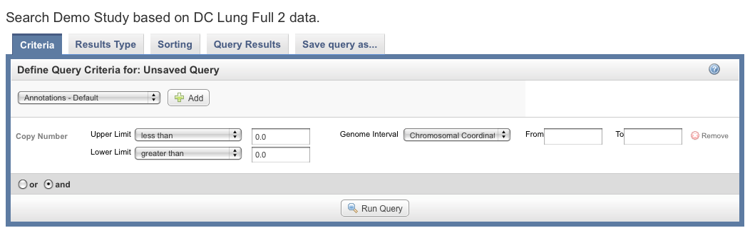

On the Results Type tab, the user sees an additional option for “Copy Number” and selects it. User clicks “Run Query”. The Query Results tab shows a data matrix containing samples vs. genomic region. Parallel to genomic region are Gene Symbols. The values in the table cells are the mean segment value as reported by caDNACopy.

++++++
below this line are for reference only, not to be implemented now.

- Summary: User wants to get a list of patients/samples that have a copy number value greater than X at any point over an interval, where the interval is entered with genomic coordinates.
- Summary: User wants to get a list of patients/samples that have a copy number value greater than X at any point over an interval, where the interval is entered as a chromosome number.
+++++
- Show me all samples which have a mean segment value greater than X (or less than X) in at least one segments and only in gene(s) XYZ.
- Show me all samples which have a mean segment value greater than X in at least one segments and only in chromosome XYZ.
- Show me all samples which have a mean segment value greater than X in at least one segment and only in and only in the regions from coordinate Y to Z.

- Number Alteration (CNA) greater than X, [where the CNA value is reported by the output of CBS (specifically caDNACopy).]
- Show me all samples which have a Copy Number Alteration (CNA) greater than X, [where the CNA value is reported by the output of CBS (specifically caDNACopy).]and only in the region of coordinate Y to Z.
- Show me all samples which have a Copy Number Alteration (CNA) greater than X, [where the CNA value is reported by the output of CBS (specifically caDNACopy).] and only in chromosome XYZ.
- Show me all samples which have a Copy Number Alteration (CNA) greater than X, [where the CNA value is reported by the output of CBS (specifically caDNACopy).] and only in gene(s) XYZ.

- Summary: User wants to get a list of patients/samples that have a GISTIC "log2ratio" greater than X and have a particular subject annotation match as well (such as age > 40.)
Details: As a study investigator, user wants to create a query combined of GISTIC results and subject annotation. Initially the user launches a GenePattern GISTIC job. After the job completes, the user initiates a new query and on the Criteria tab, adds a criterion for “Copy Number”. The criterion row contains a list of GISTIC job results names (the same names that the user entered when the GISTIC job was launched) and the user selects one. The user enters a threshold for log2ratio. On the Results Type tab, the user selects Genomic. User clicks “Run Query”. The Query Results tab shows a data matrix containing samples vs. genomic region. Parallel to genomic region are Gene Symbols. The values in the table cells are log2ratio. The table is sorted according to genomic coordinates.
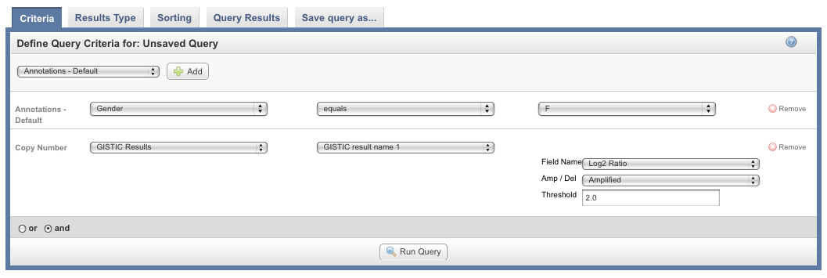
- User wants to select a GISTIC job name and save a gene list of the amplified genes from that GISTIC job as a saved list.
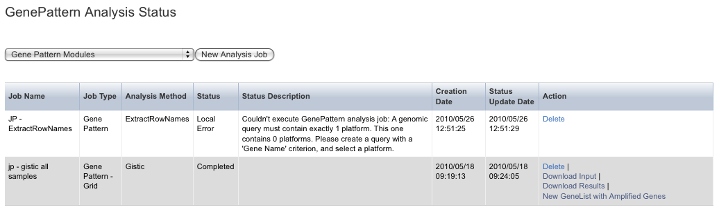
- User wants to select a GISTIC job name and save a gene list of the deleted genes from that GISTIC job as a saved list.

- Summary: User wants to get a list of genes which have a GISTIC score greater than X and have a particular subject annotation value such as age > 40.
Details: As a study investigator, user wants to create a query combined of GISTIC scores and subject annotation. Initially the user launches a GenePattern GISTIC job. After the job completes, the user initiates a new query and on the Criteria tab, adds a criterion for “Copy Number”. The criterion contains a list of GISTIC job results names and user selects one. The user enters a threshold for GISTIC Score. On the results Type tab, the user selects genomic. User clicks “Run Query”. The Query Results tab shows the matching genes sorted by genomic region. The values in the table cells are GISTIC score.

- On Query Results tab, user wants to launch an external viewer showing all samples in a genome view.
- As a study investigator, user wants to view a list of all samples that have a copy number array value exceeding a specified threshold (amplified or deleted by X) for any gene.
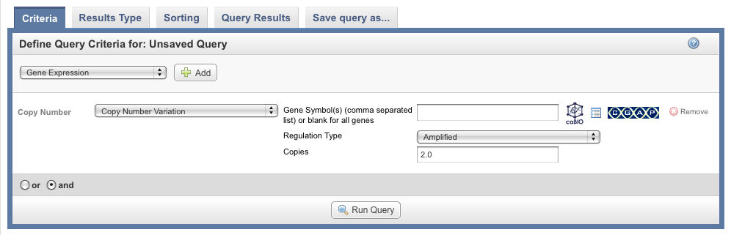
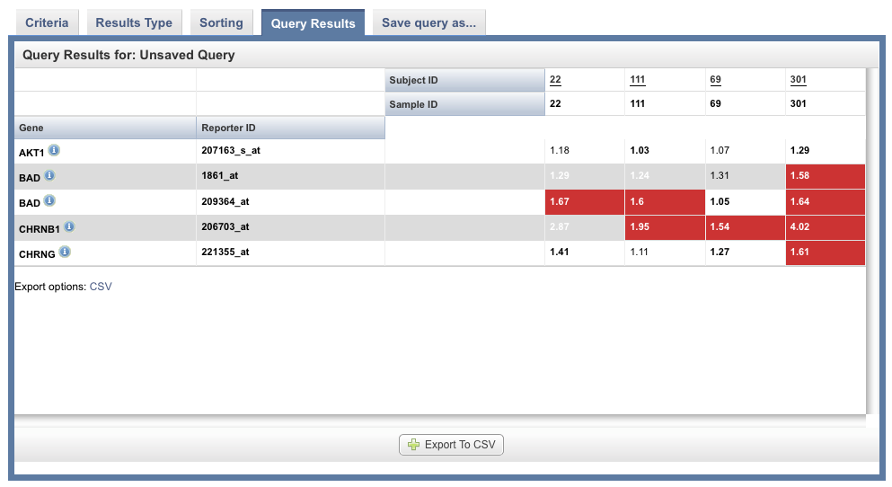

- As a study investigator, user wants to view a list of all samples that have a copy number value exceeding (or under the threshold) a specified threshold (amplified or deleted by X) for a user-provided list of genes.

- As a study investigator, user wants to take the list of samples generated in either 7 and 8 above, and further filter the list by selecting subject annotation (examples of subject annotation are disease type or gender)
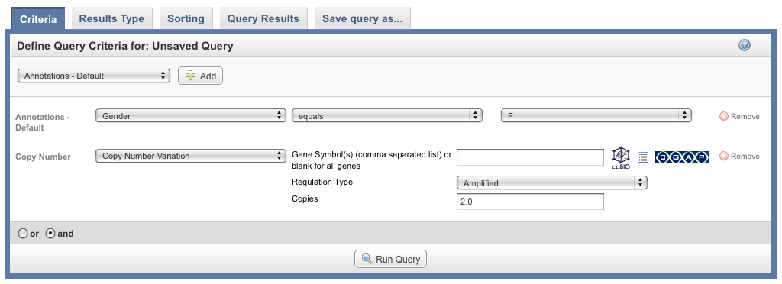

- As a study investigator, user wants to view a list of all genes and reporters that have a copy number value exceeding a specified threshold (amplified or deleted by X).

- As a study investigator, user wants to save a query that will reproduce any one of 1,2,3 above.

- User wants to use the query saved in #11, to create a KM Plot.

- As a study investigator, user wants to use the query saved in #11 above and send the copy number data to Gene Pattern GISTIC for analysis.
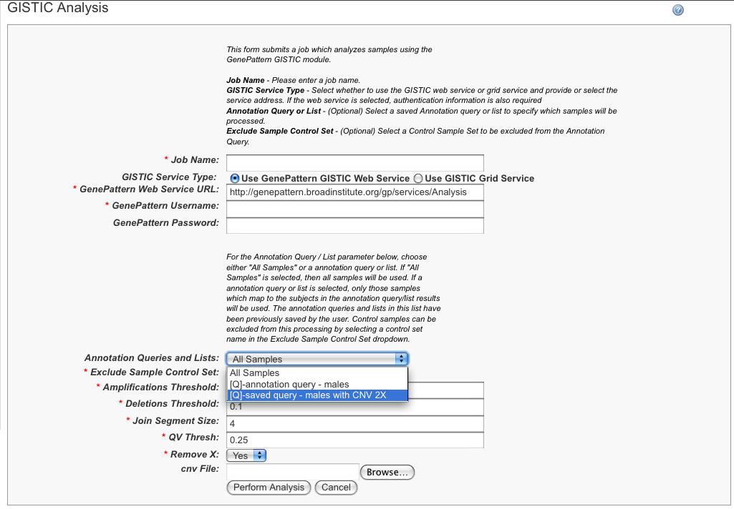

- Perform Analysis – KM Plot by Copy Number. (similar to KM Plot by GeneExpression)

- Perform Analysis – Copy Number Plot (similar to GeneExpression plot)

- Manage Studies - [Note the user stories for configuring a study to use a copy number array are already covered by existing functionality]

----------------------------------------------------------------------------

Revisions:

From 6-28 meeting:

[mtg notes] “copies” shold be “copy number”.
[mtg notes]”Regulation Type” should be “copy number threshold”.
[mtg notes] need an “unchanged” operator.
[mtg notes] q: is there statistical correlation coming from the chip data?
[mtg notes] phase1: from Query Results tab, launch viewer with all samples in a genome view.
[mtg notes] phase2: from Query Results tab, launch viewer with subset of samples and view subset of genes.

